Name: Sanio Luke Sebastian
Roll No: 35
Batch: B
Date: 06-05-2022

ADVANCED DBMS LAB

Experiment No.: 6

Aim
To familiarize with join or Cartesian product

Questions:

Using the lab cycle 06 database, perform the following queries.

- Give name of customers having living city BOMBAY and branch city NAGPUR
- Give names of customers having the same living city as their branch city
- Give names of customers who are borrowers as well as depositors and having city NAGPUR.
- Give names of borrowers having deposit amount greater than 1000 and loan amount greater than 2000.
- Give names of depositors having the same branch as the branch of Sunil
- Give names of borrowers having loan amount greater than the loan amount of Pramod
- Give the name of the customer living in the city where branch of depositor Sunil is located.
- Give branch city and living city of Pramod
- Give branch city of Sunil and branch city of Anil
- Give the living city of Anil and the living city of Sunil

Procedure & Outputs

create database lab_cycle_six;
use lab_cycle_six;

- select d1.cname from deposit d1,customer c1,branch b1 where c1.city = 'Bombay' and b1.city = 'Nagpur' and d1.cname = c1.cname and d1.bname = b1.bname;
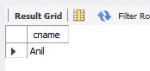

- select distinct(customer.cname), branch.city FROM branch, customer where branch.city = customer.city;
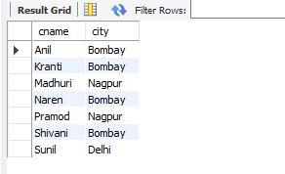

- select c1.cname from customer c1,deposit d1,borrow b1 where c1.city='Nagpur' and c1.cname=d1.cname and d1.cname = b1.cname;
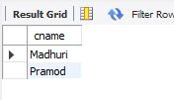

- select br1.cname, br1.amount, d1.cname, d1.amount from borrow br1,deposit d1 where d1.cname = br1.cname and d1.amount > 1000 and br1.amount > 2000;
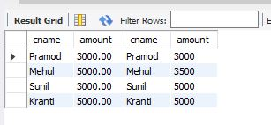

- select d1.cname from deposit d1 where d1.bname in (select d2.bname from deposit d2 where d2.cname = 'Sunil');
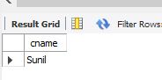

- select br1.cname,br1.amount from borrow br1 where br1.amount > all (select br2.amount from borrow br2 where br2.cname = 'Pramod');
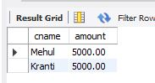

- select c.cname from customer c where c.city in (select b.city from branch b where b.bname in (select d.bname from deposit d where d.cname='Sunil'));
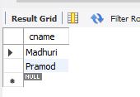

- select b1.city , c1.city from branch b1,customer c1, deposit d1 where c1.cname = 'Pramod' and c1.cname = d1.cname and d1.bname = b1.bname;
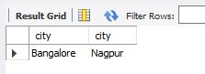

- select d1.cname, b1.city from deposit d1, branch b1 where d1.bname = b1.bname and d1.cname in ('Sunil' ,'Anil');
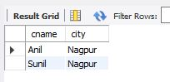

- select c1.cname, c1.city from customer c1 where c1.cname = 'Anil' or c1.cname = 'Sunil';

